ERP Form SRS
1. Introduction
The introduction section provides an overview of the software project. It gives a brief explanation of what the ERP system is, what it is intended to do, and who will use it.
1.1 Purpose
This document outlines the software requirements for the ERP Form and Dashboard Web Application. The system is designed for students to fill out their ERP forms online and send their data to their dedicated organization and view their submitted data through a personalized dashboard. The purpose is to digitize the form-filling process, maintain records efficiently, and provide easy access to students and administrators.
1.2 Scope
This system will allow students to:
- Register and log in to their account.
- Fill out and submit a detailed ERP form including personal, academic, and family information.
- Upload supporting documents.
- View their submitted data in a structured dashboard format (not yet implemented)
Administrators will be able to:
- View all student submissions.
- Verify data and documents.
- Manage records centrally.
The application will use a Flask backend with an HTML/CSS frontend and a MySQL database for storing data.
1.3 Intended Audience
This document is intended for:
- The development team
- The project supervisor or HOD
- Testers
- End-users (students and admins)
1.4 Definitions, Acronyms, and Abbreviations
- ERP: Enterprise Resource Planning
- UI: User Interface
- DB: Database
- SRS: Software Requirements Specification
- Flask: A lightweight Python web framework

2. Overall Description

2.1 Product Perspective

This ERP system is a web-based application that allows students to fill out a digital ERP form with personal, academic, and contact details. The data is stored in a MySQL database and can be accessed later via a secure dashboard. The system uses Flask (Python) as the backend, and HTML/CSS for the frontend.

It is a standalone application meant for internal university usage and is accessible through standard web browsers.

System Architecture Diagram:
HTML/CSS
(On browser access)
Python with
Flask
My SQL Database, Backend side.
2.2 Product Functions

Key functions of the system include:
- User Registration & Login: Users create accounts or log in using credentials.
- ERP Form Submission: Authenticated users can fill out a detailed form (with file uploads).
- Dashboard View(not yet implemented): Users can view their submitted ERP data presented neatly in a tabular format.
- Session Management & Logout: Ensures users remain logged in only during active sessions.
- Navigation Links: Links to ERP form, dashboard, logout, and registration are available.
- Data Validation: Basic form validation is applied both on frontend and backend.

2.3 User Classes and Characteristics

User Type | Characteristics
Student | Primary user who fills the ERP form and views it on dashboard.
Admin (future) | Can manage student data, monitor submissions (currently not implemented but can be planned).

This section describes different types of users and their technical expertise.
- Basic computer skills required
- Should know how to use browser, upload files, etc.
2.4 Operating Environment
This web application will run in the following environment:
- Frontend: HTML, CSS (possibly Bootstrap)
- Backend: Python (Flask Framework)
- Database: MySQL
- Browser Compatibility: Chrome, Firefox, Edge (latest versions)
- Server: Flask runs on localhost.

2.5 Design and Implementation Constraints
These are limitations or conditions that impact development:
- Technology Stack Constraint: Only Python + Flask + MySQL stack is used.
- Single-user access: Currently designed for individual students (not multi-admin support).
- Security: To ensure the safety of the users, the passwords will be saved in encrypted format using hashing method.
- Static deployment: Requires manual deployment or local server setup.
2.6 Assumptions and Dependencies
Assumption | Explanation
User has basic knowledge of web forms | To fill and submit ERP form properly
Internet connection is stable | Required for accessing the web interface
Flask server is running | Backend must be hosted and active
MySQL database is preconfigured | Required for data storage and retrieval

Dependencies:
- Flask (and related Python packages)
- MySQL Server
- A running web browser

3. Specific Requirements
- This section describes the detailed functional and non-functional requirements of the ERP form system. Here’s how it should be structured:
3.1 External Interface Requirements
3.1.1 User Interfaces
The application includes the following user interface components:
- Login Page: Fields for email and password, with error messages for invalid credentials.
- Registration Page: Fields for new users to register with email, name, and password.
- ERP Form Page: Contains personal, academic, and document upload fields in a structured layout.
- Dashboard Page: Displays submitted form data in a table based on the logged-in user.
- Navigation Bar: Links to Dashboard, ERP Form, Register, and Logout.
3.1.2 Hardware Interfaces
- Runs on standard desktop/laptop with internet and browser access.
- No direct hardware interaction is involved.

3.1.3 Software Interfaces
- Flask Framework (Python) – Handles routing and backend processing.
- MySQL – Database to store user credentials and form data.
- HTML/CSS/JS – Frontend form and dashboard display.
- Browser – Client-side interface (Chrome recommended).
3.1.4 Communication Interfaces
- HTTP/HTTPS protocols used for browser-server communication.
- Flask routes handle client requests like /register, /login, /dashboard, and /form.

3.2 Functional Requirements
These define what system must do:
Function | Description
User Registration | Allows new users to register with name, email, and password.
User Login | Authenticates existing users with email and password.
Form Submission | Authenticated users can fill in and submit the ERP form.
Data Storage | Stores user info and form data in the database.
Dashboard Display | Logged-in users can view their form data in tabular format(yet to be implemented).
File Uploads | Allows uploading of photo, caste/residence/income certificates.
Logout | Ends the user session and redirects to the login page.
3.3 Non-Functional Requirements
These are quality attributes of the system:
Requirement Type | Description
Performance | Should respond to user actions within 1-2 seconds.
Usability | Simple and intuitive UI for students with basic knowledge.
Reliability | Data should be saved correctly and persist across sessions.
Security | Passwords should be hashed; forms should use CSRF tokens (optional).
Portability | Runs on any OS with Python and browser support.
Maintainability | Code is modular and separated into templates and routes.
3.4 Logical Database Requirements
Table | Fields
users | id, name, email, password (hashed)
form_data | id, fname, lname, dob, address, documents (paths), etc.
These are two different tables in the same database containing two separate information.
3.5 Validation Rules
- Phone Number must be 10 digits.
- Email must follow correct format (e.g., user@gmail.com).
- Mandatory Fields must be filled.
- File Uploads must accept only valid file types and size limits.
- Date of Birth must be in proper format.

4. External Interface Requirements
This section describes how ERP system will interact with users, hardware, software, and communications interfaces.
We'll go through each subsection one by one:
4.1 User Interfaces
This defines how users will interact with the system — the forms, dashboards, buttons, links, and general UI.
Explanation:
The system will have a web-based user interface that is designed to be simple and intuitive. It will include the following:
- A Login page where users (students/admins) can securely access the system using their credentials.
- A Registration page for new users to sign up.
- An ERP Form page for students to submit personal, academic, and document details.
- A Dashboard where users can view submitted data and perform actions (like viewing status).
- Navigation links like “Back to Dashboard,” “Register here,” and “Logout” to improve usability.
4.2 Hardware Interfaces
Explanation:
- The system does not require any specialized hardware.
- It can be accessed on any device (PC, laptop, tablet, smartphone) with a standard web browser and internet connection.
- Server-side scripts will run on a computer/server with Python and Flask installed.
4.3 Software Interfaces
This section explains the software environment and tools used to build and run the application.
Explanation:
The application will use the following software tools and platforms:
- Frontend: HTML5, CSS3, JavaScript
- Backend: Python 3.11 with Flask framework

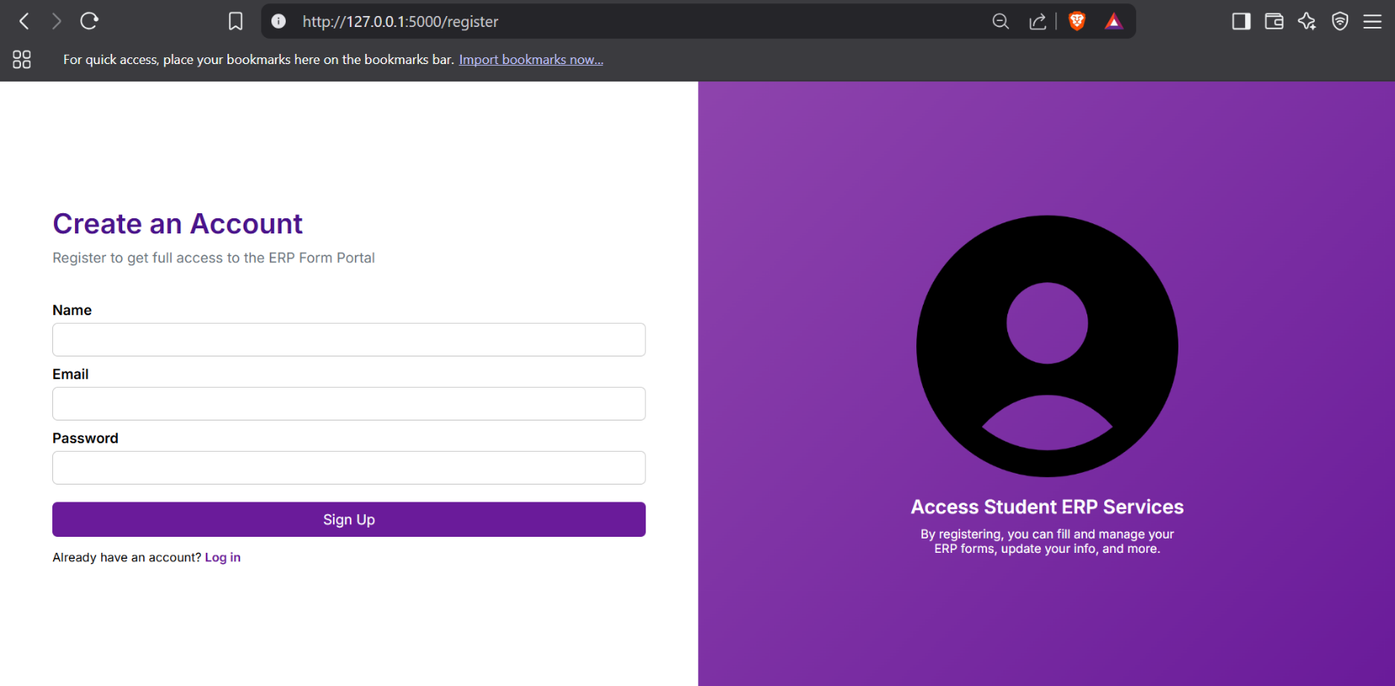
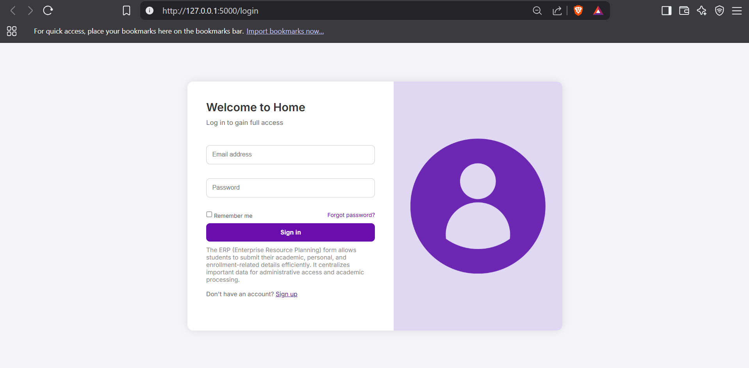
  - Home / Landing Login page

  - Registration Page if user not registered

5. System Features
5.1 ERP Form
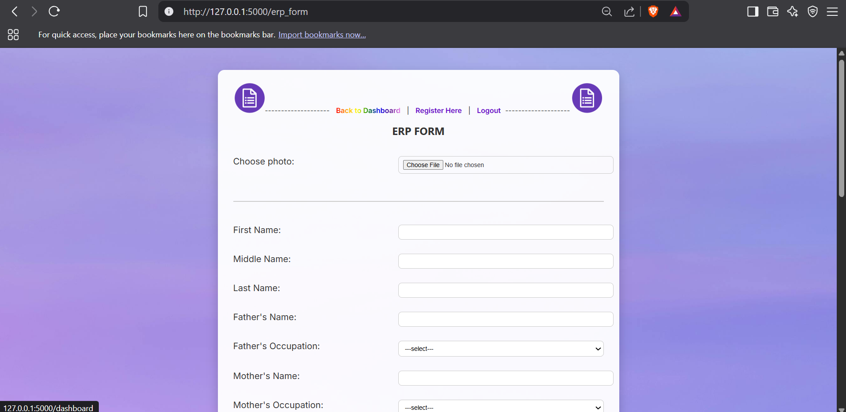
Allows authenticated users to input detailed personal and educational information and upload supporting documents.

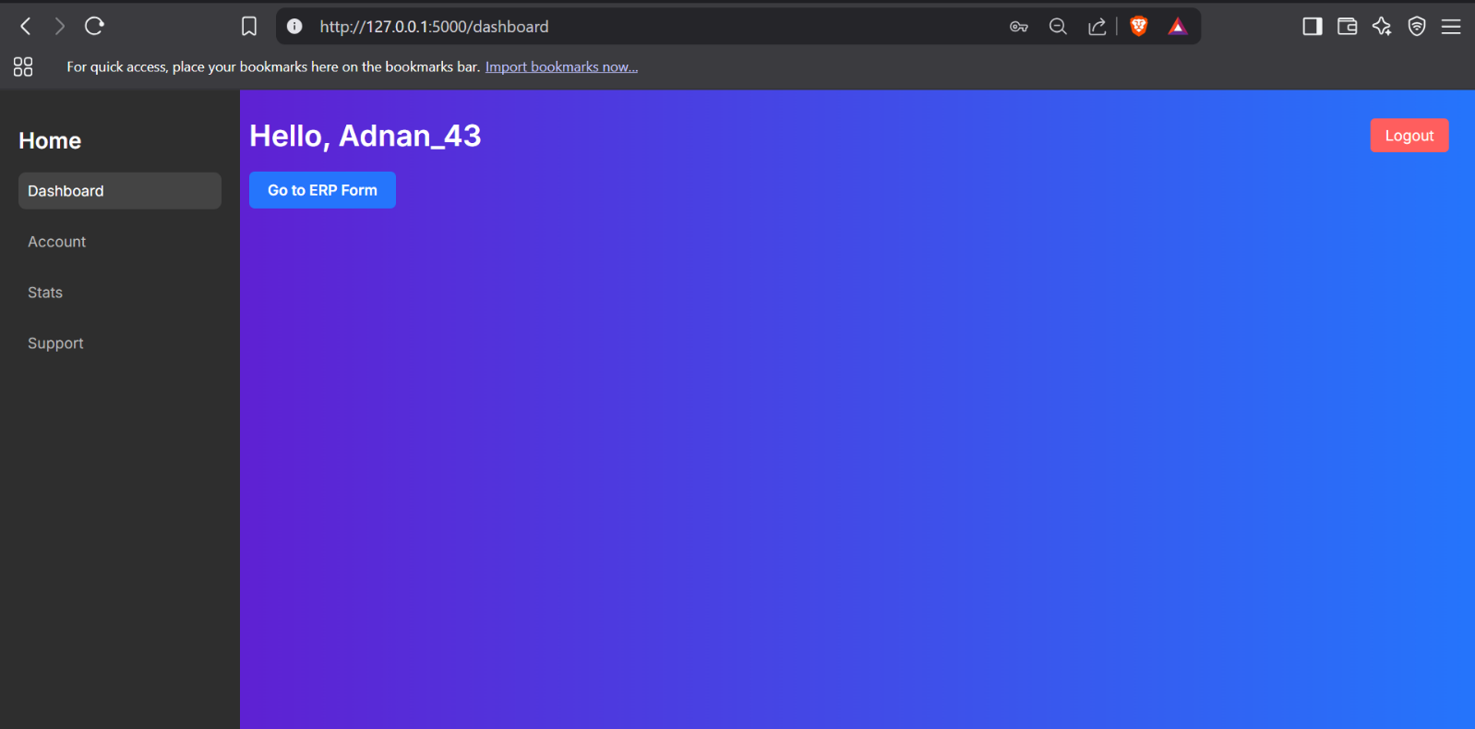
5.2 Dashboard
Displays submitted ERP information specific to the logged-in user in a visually organized format.
5.3 User Authentication
Ensures that only registered users can log in. Session data is used to maintain state across pages.
5.4 Logout and Session Management
Users are logged out manually or on session expiry. Sessions are handled using Flask’s built-in session management.
6. Other Requirements
6.1 Database Schema
The system uses two main tables:
- users: Stores user credentials (id, username, email, password)
- erp_data: Stores form data (id,, fname, mname, lname, dob, etc.)
the id and password gets saved in “users” table whereas erp_data saves the ERP form information.

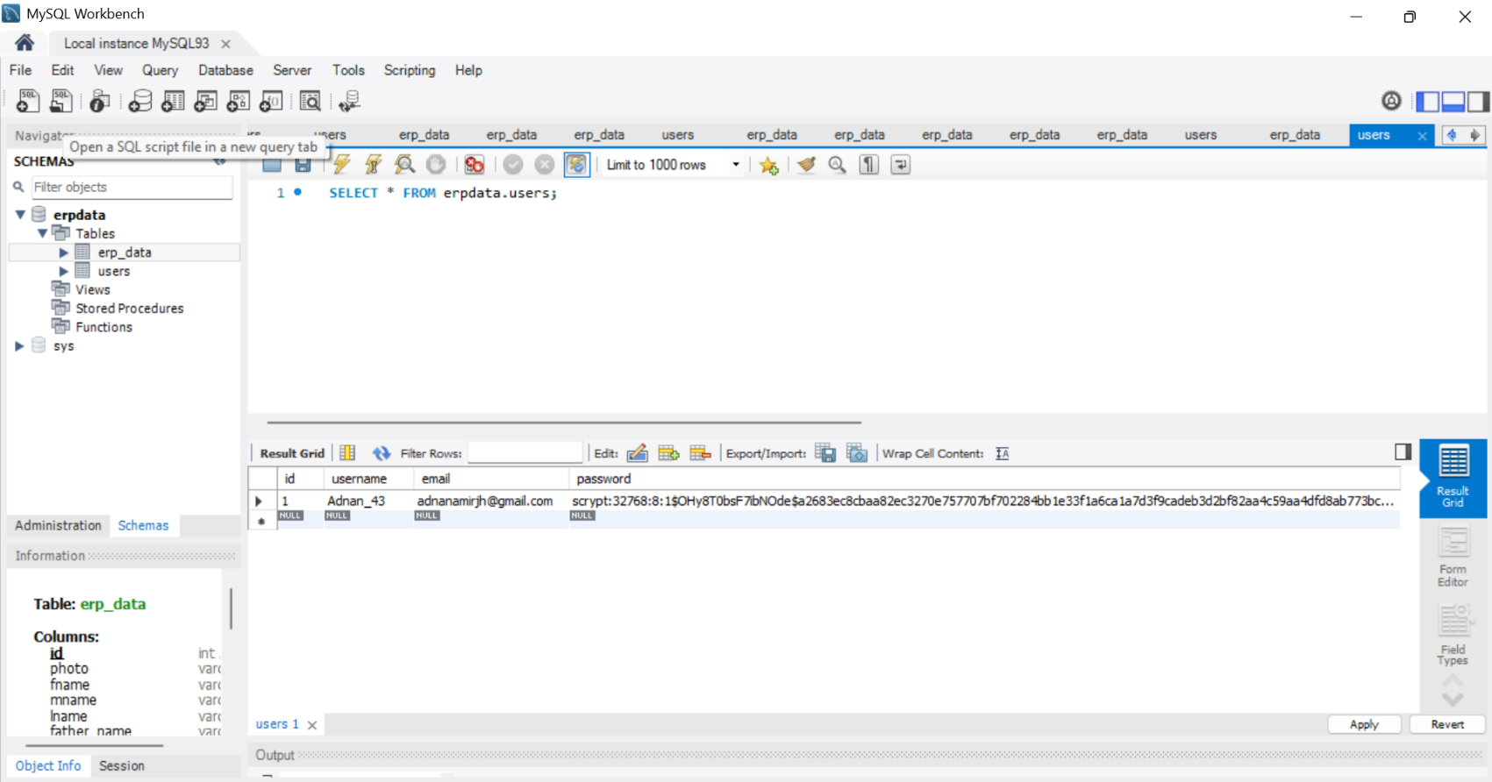
  - users table which contains the private credentials

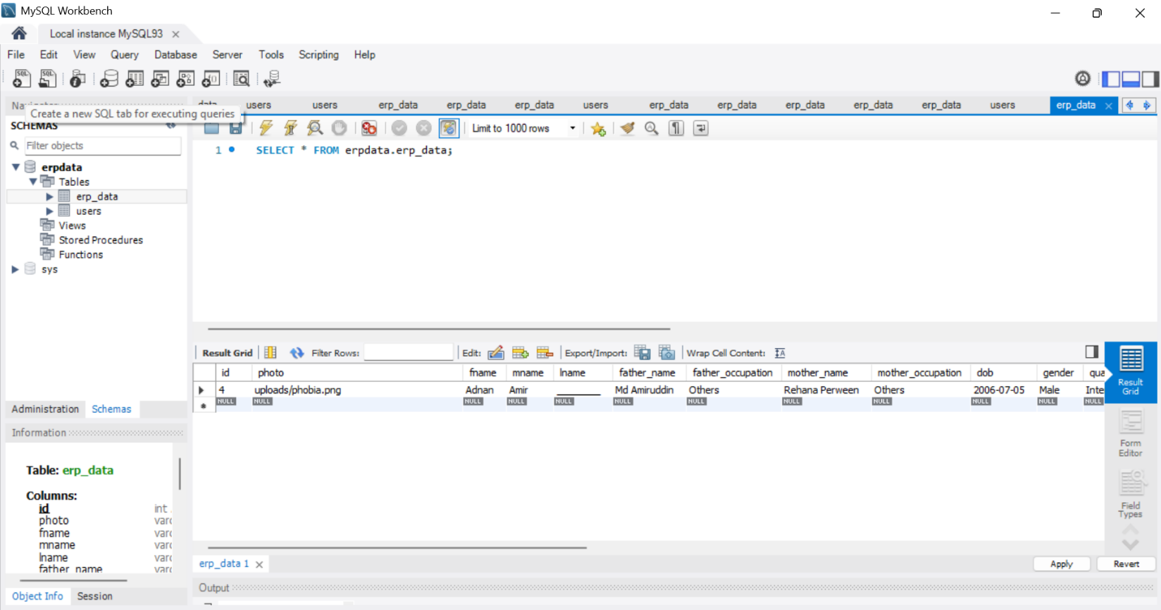
  - erp_data table which contains the erp form information.
6.2 Data Flow Diagrams (DFD Level 0 and Level 1)
Include diagrams showing data flow between user, form, backend processing, and database.
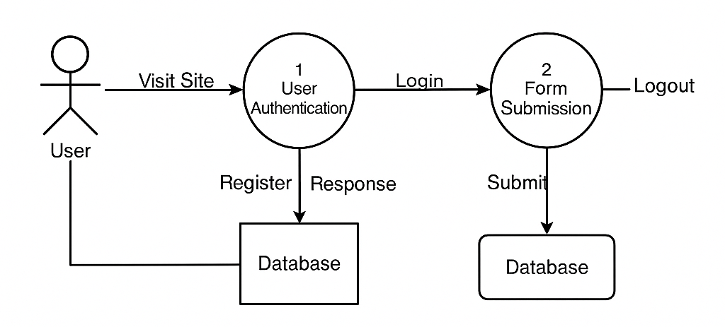
Admin

6.3 ER Diagram
Entity-relationship diagram showing the logical structure of the database, including the relationship between users and ERP form data and webpages.
Erp_data
Database

Python Flask app
Erp form
Login
Sign up
Dashboard
users

6.4 Use Case Diagram
Depicts actors (students, future admin) and their interaction with the system features.
New User
Registersv
Login
Database
Erp form
Dashboard
Log out
Admin
Admin handle

*In future goals more expansions will be done like:
- More new features
- More leisure interactions on home page
- The main implementation of users can view their data on their dashboard
- Also user can see their progress according to their performance
- More feedback implementation

